|  |  |  |  |  |  |  |
| --- | --- | --- | --- | --- | --- | --- |
| sector_header | | | | | | |
|  | **NLP4StatRef: Methodological support on advanced methods for accessing, ingesting and linking textual information using semantic analysis and natural language processing** | | | | | |
| partner_flag1  partner_flag2 | Knowledge Database Documentation | | | | | |
|  | | | | | |
|  | | | | | |
| Specific contract N° 000068  Under  Framework Contract N° 2018.0088, Lot 1: Methodological support | | | | | |
|  |  | evaluation_03 |  | evaluation_01 |  |  |
|  | April 2022 | | | | | |

#### NLP4StatRef Ontology ¤ Classes

| Class | Usage note | URI | Reference |
| --- | --- | --- | --- |
| Classification | All types of controlled Category, Types, Topics, and others | estat:Classification | http://nlp4statref/ontology# Classification |
| Category | A class that represents the Categories that EuroStat offers | estat:Category | http://nlp4statref/ontology# Category |
| GlossaryArticleCategory | A class that contains the categories for the Glossary Articles | estat:GlossaryArticleCategory | [http://nlp4statref/ontology#GlossaryArticleCategory](http://nlp4statref/ontology#GlossaryArticleCategory ) |
| StatisticsExplainedCategory | A class that contains the categories for the Statistics Explained Articles | estat:StatisticsExplainedCategory | http://nlp4statref/ontology#StatisticsExplainedCategory |
| Topic | A class that represents the topics, given by the collegues at Quantos | estat:Topic | https://www.w3.org/TR/skos-reference/#Topic |
| Type | A class that contains various types, statistical units, and measurement units among others | estat:Type | http://nlp4statref/ontology#Type |
| ConceptType | A class with the concept types | estat:ConceptType | http://nlp4statref/ontology#ConceptType |
| InfoType | A class with the Information types | estat:InfoType | http://nlp4statref/ontology#InfoType |
| LexicalType | A class with the lexical types | estat:LexicalType | http://nlp4statref/ontology# LexicalType |
| MeasurementType | A class with the measurement unit types | estat:MeasurementType | http://nlp4statref/ontology# MeasurementType |
| StatisticalType | A class with the statistical unit types | estat:StatisticalType | http://nlp4statref/ontology# StatisticalType |
| StatusType | A class with the status types | estat:StatusType | http://nlp4statref/ontology# StatusType |
| Content | All types of described and annotated content. | estat:Content | http://nlp4statref/ontology#Content |
| Article | All the information written and published around the statistical data, to comment on them and explain them. | estat:Article | http://nlp4statref/ontology#Article |
| StatisticsExplainedArticle | A class with the statistics explained articles | estat:StatisticsExplainedArticle | http://nlp4statref/ontology#StatisticsExplainedArticle |
| Glossary Article | A class with the Glossary Articles | estat:GlossaryArticle | http://nlp4statref/ontology#GlossaryArticle |
| BackgroundArticle | A class with the Statistics Explained Articles that are also Background Articles | estat:BackgroundArticle | http://nlp4statref//ontology#BackgroundArticles |
| Statistical Data | Abstract class for statistical content of the datasets | estat:StatisticalData | http://nlp4statref/ontology#StatisticalData |
| GlossaryTerm | All types of controlled vocabularies, dictionaries, and others. | estat:GlossaryTerm | http://nlp4statref/ontology#GlossaryTerm |
| Code | A class that contains the codes that the statistical datasets are related to | estat:Code | http://nlp4statref/ontology#Code |
| CODEDTerm | Glossary is an alphabetical list of terms relating to a specific subject enriched by definitions and related content. | estat:CODEDTerm | http://nlp4statref/ontology#CODEDTerm |
| NamedEntity | A class that contains the named entities existing in EuroStat Content Dataset | estat:NamedEntity | http://nlp4statref/ontology# NamedEntity |
| OECDTerm | A class that represents the OECD data | estat:OECDTerm | http://nlp4statref/ontology#OECDTerm |
| Theme | A class that represents the Themes that EuroStat offers | estat:Theme | http://nlp4statref/ontology#Theme |
| Paragraph | A class that contains the information for the paragraphs of the Statistics Explained Articles | estat:Paragraph | http://nlp4statref/ontology#Paragraph |
| OECDTheme | A class that contains the OECD themes | estat:OECDTheme | http://nlp4statref/ontology#OECDTheme |
| EurostatTheme | A class with the Eurostat themes | estat:EurostatTheme | http://nlp4statref/ontology#EurostatTheme |
| WebSource | A class which has two subclasses that represent Internal Links (i.e., links that refer to EuroStat entities) and External Links (i.e., links that refer to entities out of EuroStat). | estat:WebSource | http://nlp4statref/ontology#WebSource |

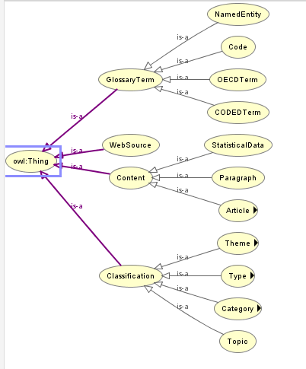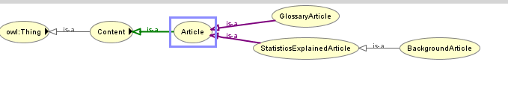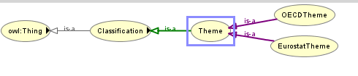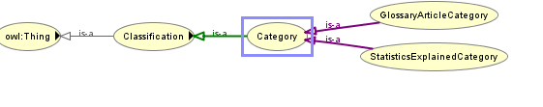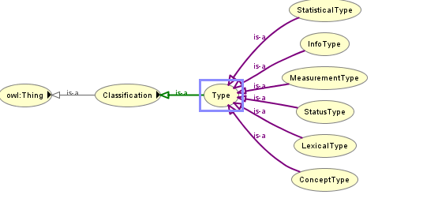

#### NLP4StatRef Ontology ¤ Object Properties

| Property | URI | Domain | Range | Usage |
| --- | --- | --- | --- | --- |
| hasClassification | estat:hasClassification | estat:Content | estat:Classification | A property that shows if an article from the Editorial Content has any Classification |
| hasCategory | estat:hasCategory | estat:Content | estat:Category | A property that relates an article from the Editorial Content with its Categories |
| hasCategoryOfGlossaryArticle | estat:hasCategoryOfGlossaryArticle | estat:GlossaryArticles | estat: GlossaryArticleCategory | A property that relates an article from the glossary category with its category(-ies) |
| hasCategoryOfStatisticExplainedArticle | estat:hasCategoryOfStatisticExplainedArticle | estat:StatisticsExplainedArticles | estat:StatisticsExplainedCategory | A property that relates an article from the statistics explained category with its category(-ies) |
| hasTopic | estat:hasTopic | estat:Content | estat:Topic | A property that relates an article from the Editorial Content with its Topics |
| hasType | estat:hasType | estat:Content | estat:Type | Some articles from the Editorial Content may have some information about their lexical type, status type, and others |
| hasGlossaryTerm | estat:hasGlossaryTerm | estat:Content | estat:GlossaryTerm | A property that shows if an article from the Editorial Content has any Glossary Term |
| hasCode | estat:hasCode | estat:StatisticalData | estat:Code | A property that relates a dataset to its code(-s). Basically is the labels of the Statistical Data |
| hasNamedEntity | estat:hasNamedEntity | estat:Content | estat:NamedEntity | A property that relates an article from the Editorial Content with the named entities that it contains |
| hasTerm | estat:hasTerm | estat:Content | estat:CODEDTerm OR estat:OECDTerm | A property that relates the entities from the content class with its terms |
| hasCODEDTerm | estat:hasCODEDTerm | estat:Content | estat:CODEDTerm | A property that relates entities from the Editorial Content with the CODED Terms |
| hasOECDTerm | estat:hasOECDTerm | estat:Content | estat:OECDTerm | A property that relates entities from the Editorial Content with the OECD Terms |
| hasTheme | estat:hasTheme | estat:Content | estat:Theme | A property that relates the Editorial Content entities with their Theme(-s) |
| hasWebSource | estat:hasWebSource | estat:Content OR estat:CODEDTerm OR estat:OECDTerm | estat:WebSource | A property that displays the Web Sources |
| mapsToTheme | estat:MapsTheme | estat:OECDTheme | estat:EurostatTheme | A property that relates a OECD Entity with the EuroStat Theme(-s) |
| hasParagraph | estat:hasParagraph | estat:StatisticsExplainedArticles | estat:Paragraph | A property that relates the Statistics Explained Articles with its paragraphs |
| hasOECDTheme | estat:hasOECDTheme | estat:OECDTerm | estat:OECDTheme | A property that relates the OECD themes with the OECD terms |

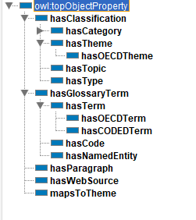

#### NLP4StatRef Ontology ¤ DataType

The classes created to describe the relevant data to meet the use cases are the following:

| Property | URI | Domain | Range | Usage |
| --- | --- | --- | --- | --- |
| content | estat:content | estat:Article | xsd:string | This property relates the articles from the editorial content with their Content (i.e., their Abstract or a small Description) |
| context | estat:context | estat:Article OR estat:OECDTerm | xsd:string | A property that relates the Articles from the Editorial Content with their context (a small description of the context that the article is applicable to) |
| dataSource | estat:dataSource | estat:Article | xsd:string | A property that connects the articles from the Editorial Content with their Data Source(-s) (which are strings) |
| dateCreated | estat:dateCreated | estat:Content OR estat:GlossaryTerm | xsd:dateTimeStamp | A property that relates a glossary entity with its creation date |
| dateUpdated | estat:dateUpdated | estat:Content OR estat:GlossaryTerm | xsd:dateTimeStamp | A property that relates a glossary entity with the date that was updated |
| definition | estat:definition | estat:CODEDTerm OR estat:OECDTerm | xsd:string | A property that relates a glossary entity with its definition |
| fileDescription | estat:fileDescription | estat:StatisticalData | xsd:string | A property that relates a dataset with its file description |
| Id | estat:id | estat:Content OR estat:GlossaryTerm OR  estat:StatisticalData | xsd:integer | A property that indicates the ID of the glossary or the content entity |
| keyword | estat:keyword | estat:Topic | xsd:string | A property that relates the an instance from the class Topic with its keyword(-s) |
| term | estat:term | estat:GlossaryTerm | xsd:string | A property that indicates the label of the dataset and the label of the Vocabulary entity |
| level | estat:level | estat:StatisticalData | xsd:string | A property that indicates the depth that the dataset is in the Statistical Data tree |
| paragraph | estat:paragraph | estat:Paragraph | xsd:string | A property that relates a paragraph from the paragraph class with its context |
| remark | estat:remark | estat:CODEDTerm | xsd:string | A property that relates a glossary entity with its remark |
| sourcePublication | estat:sourcePublication | estat:OECDTerm | xsd:string | A property that relates the OECD enities with their source Publication |
| title | estat:title | estat:Content OR estat:GlossaryTerm | xsd:string | This property relates the articles from the editorial content with their Title |
| url | estat:url | estat:WebSource | xsd:anyURI | A property that displays the URL(s) |
| isExternal | estat:isExternal | estat:WebSource | xsd:boolean | A property that indicates if the Web Source is internal (i.e., represents an Eurostat entity) or external (i.e., represents an entity not existing in EuroStat). True value indicates an external we source. |
| linkID | estat:linkID | estat:WebSource | xsd:integer | A property that indicates the ID of the link. The ID is given by EuroStat |

Εικόνα που περιέχει πίνακας

Περιγραφή που δημιουργήθηκε αυτόματα

Moreover, the NLP4StatRef-Ontology-datasets-v2.owl.owl file contains the hierarchy of the eurostat datasets that exist in the content database